Lab Guide 6

ConfigMap & Secret

Q.1 CREATE A YAML TO DEPLoy database with some env variable
MYSQL_ROOT_PASSWORD=redhat
MYSQL_DATABASE=mayank
MYSQL_USER=test1
MYSQL_PASSWORD =qwerty
Q.2 create a configmap with test1cm name and give 4 values as above
Q.3 create a secret with type generic and name of secret should be test1secret and give 4 values as above
Q.4 use test1cm configmap to create a pod using mysql image by yaml
Q.5 use test1secret secret to create a pod using mysql image by yaml

Ans: 1

oc run mydb --image mysql --env MYSQL_ROOT_PASSWORD=redhat --env MYSQL_DATABASE=mayank --env MYSQL_USER=test1 --env MYSQL_PASSWORD=qwerty --dry-run -o yaml > mydb.yaml

oc get pods
oc describe pod mydb
oc exec -it mydb – bash
mysql –uroot –p enter
redhat
show databases;
env
exit
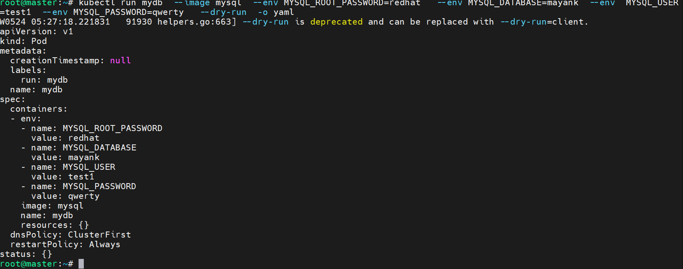

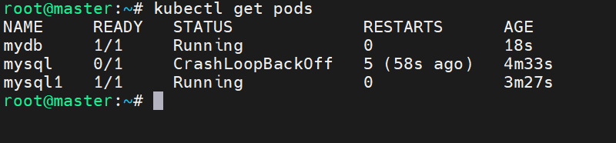

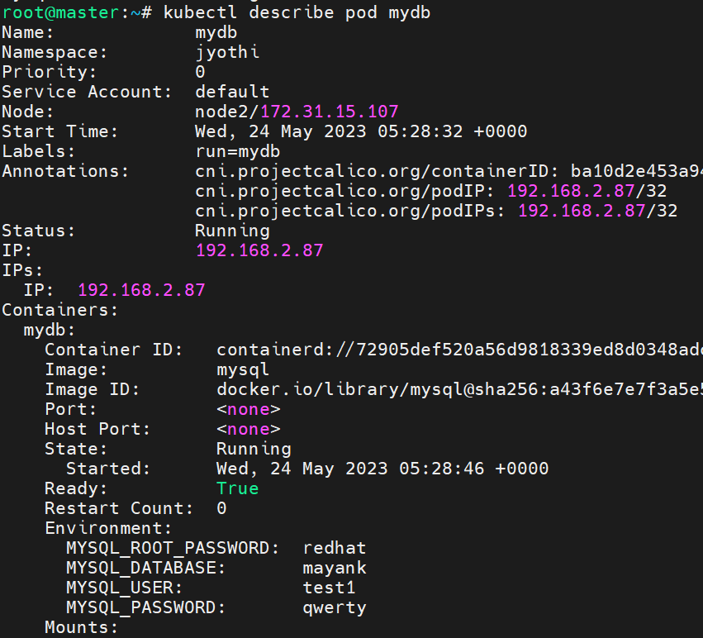
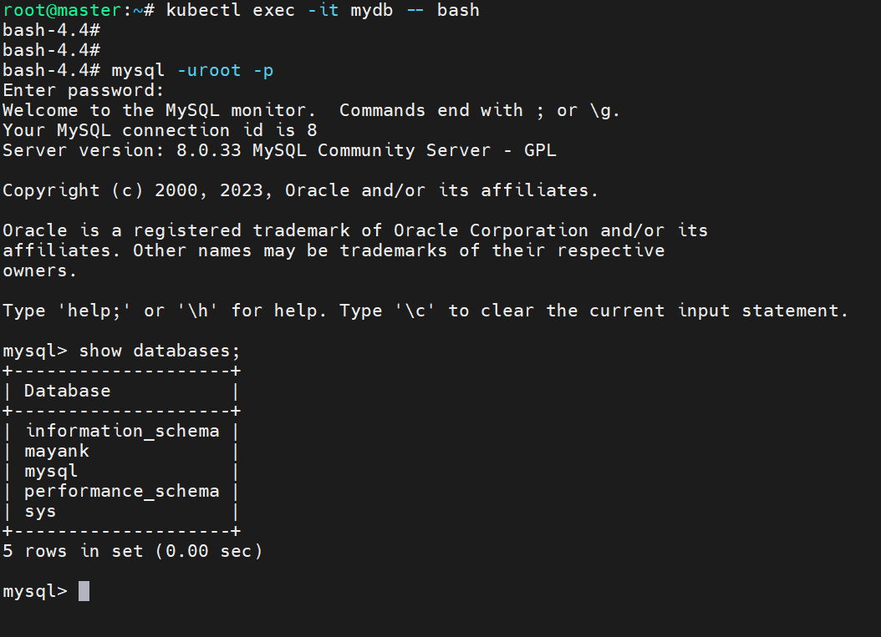
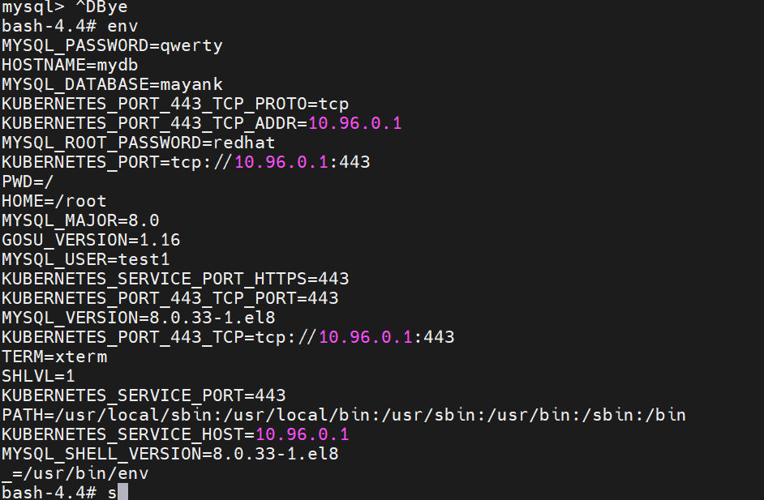

ANs: 2
vim mayankenv
cat mayankenv
oc create configmap test1cm --from-env-file mayankenv
oc get cm
oc describe cm test1cm
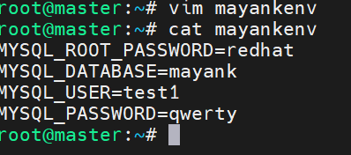
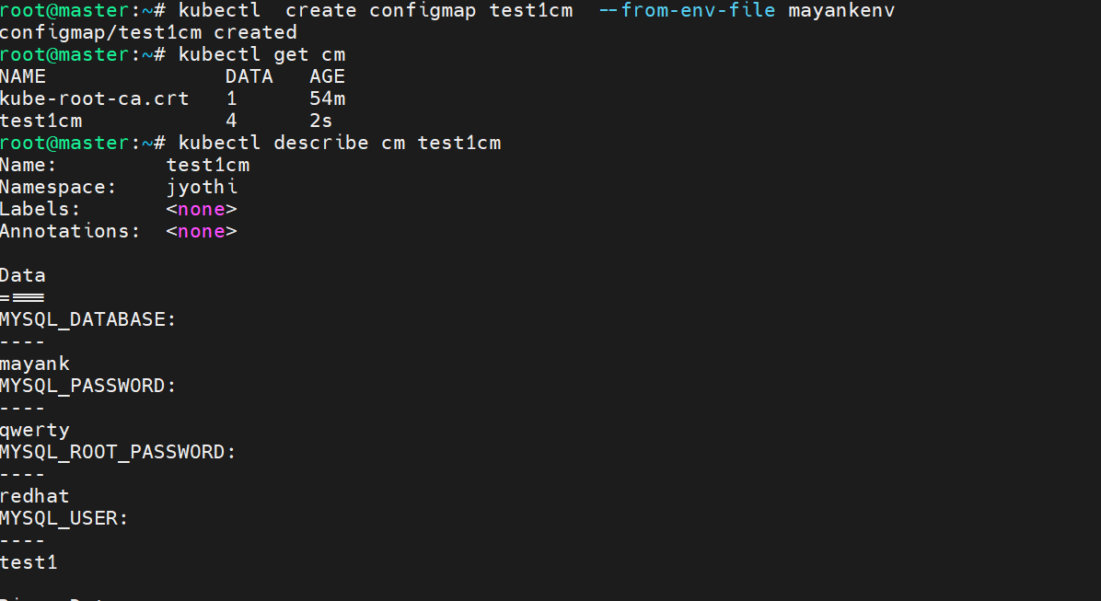

Ans: 3
oc create secret generic test1secret --from-env-file mayankenv
oc get secret
oc describe secret test1secret
oc edit secret test1secret
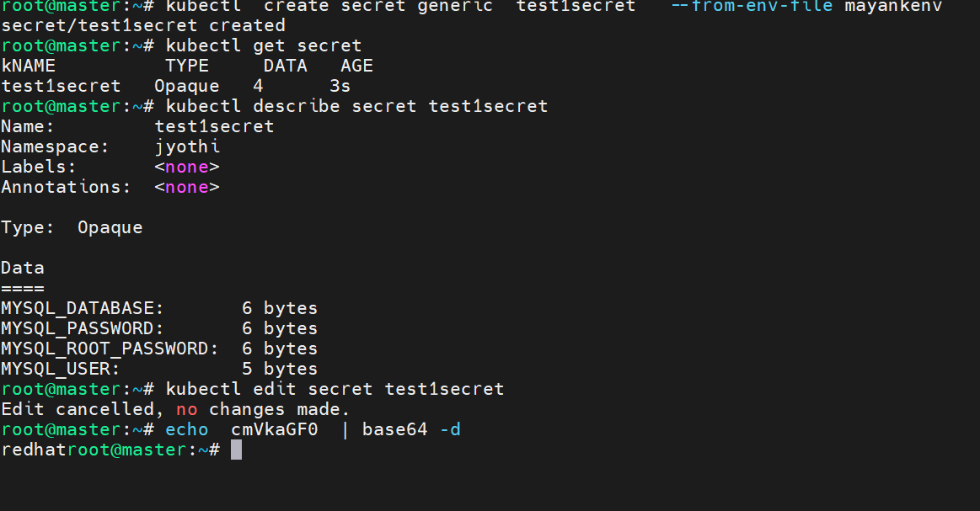
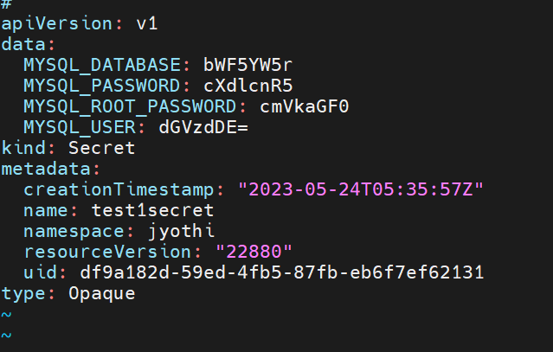

Ans: 4

vim cmmydb.yaml
cat cmmydb.yaml
oc create -f cmmydb.yaml
oc get pods
oc describe pod cmmydb
oc exec -it cmmydb -- env
oc exec -it cmmydb -- mysql -uroot -p
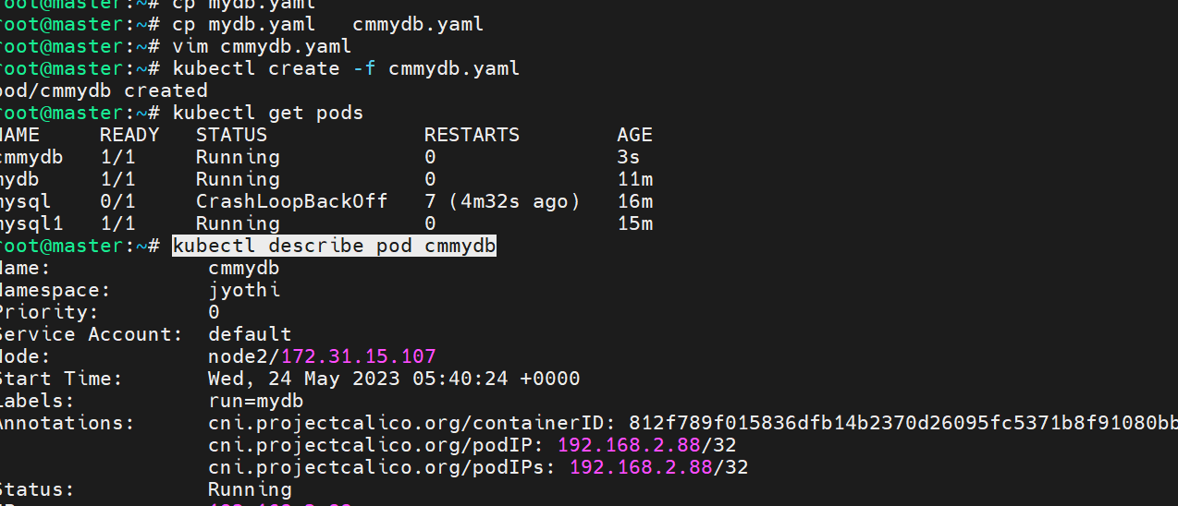

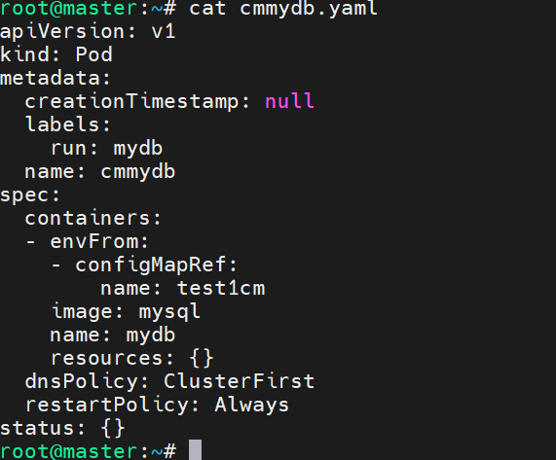
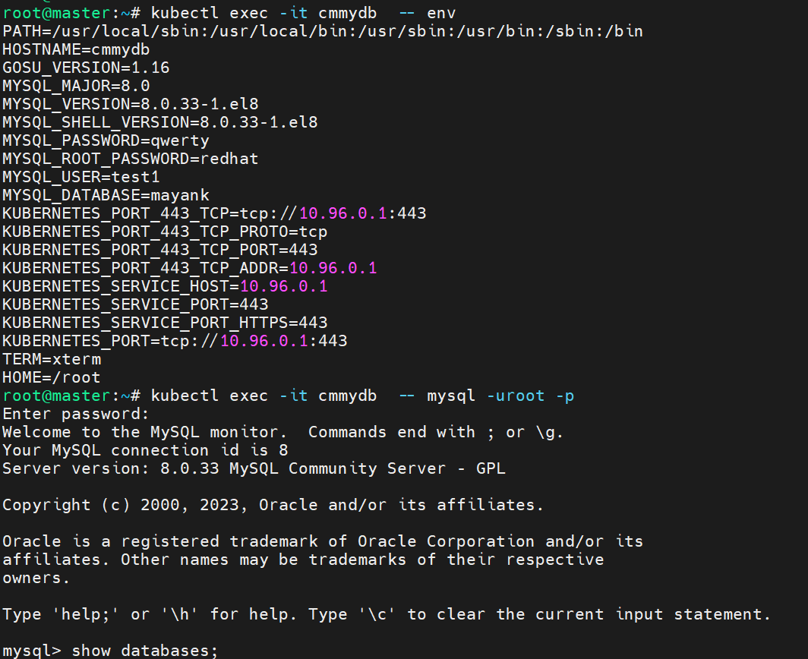

Ans: 5
vim secretmydb.yaml
cat secretmydb.yaml
oc create -f secretmydb.yaml
oc get pods
oc describe pod secretmydb
oc exec -it secretmydb – env
oc exec -it secretmydb -- mysql -uroot –p

